P Sai Koushik
2200032991
assertion testing junit testing
Out put
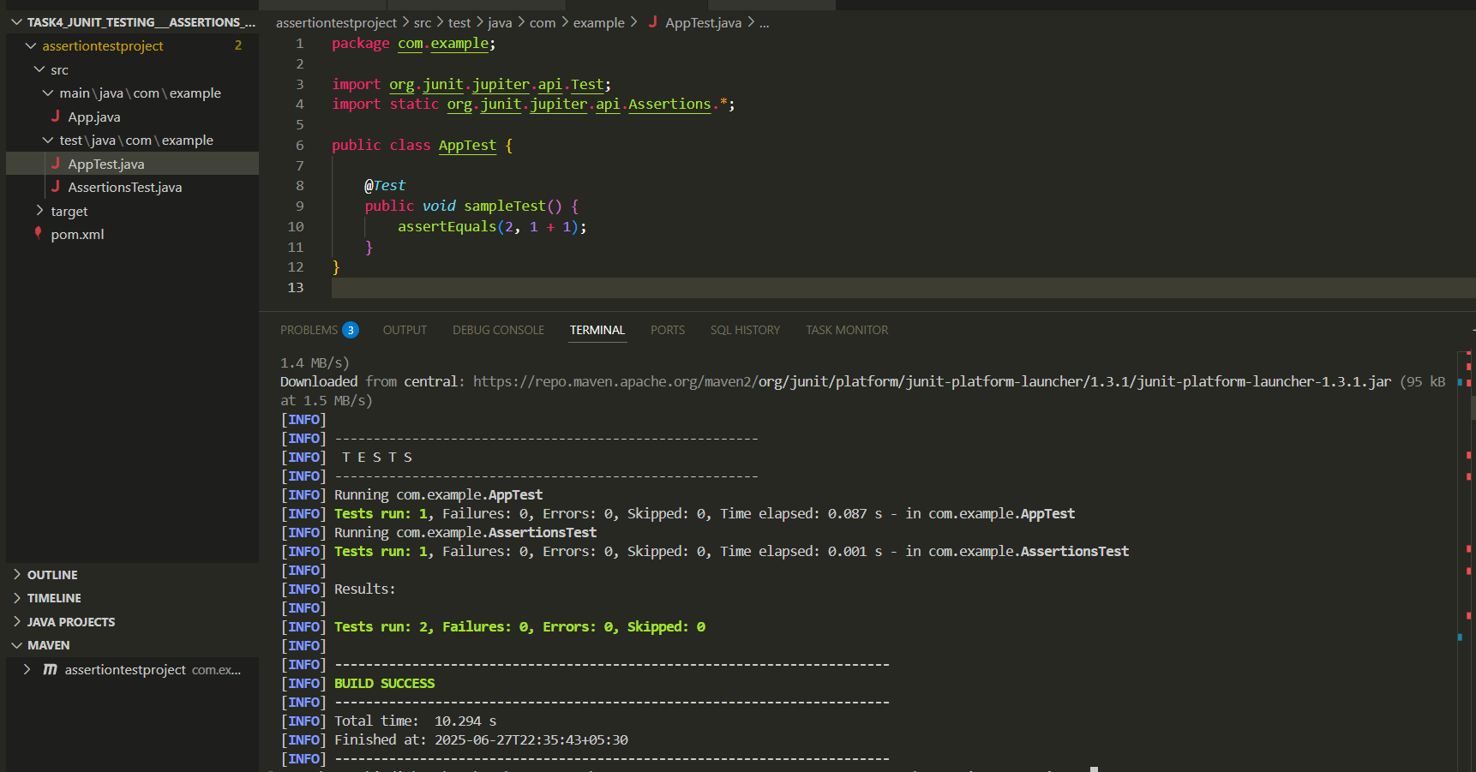

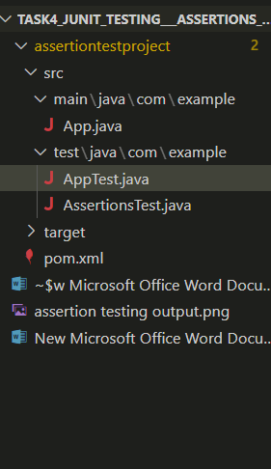

Assertiontest.java
package com.example;

import org.junit.jupiter.api.Test;
import static org.junit.jupiter.api.Assertions.*;

public class AppTest {

@Test
public void sampleTest() {
assertEquals(2, 1 + 1);
}
}

App.java
package com.example;

public class App {
public static void main(String[] args) {
System.out.println("Hello from App.java!");
}
}

Apptest.java
package com.example;

import org.junit.jupiter.api.Test;
import static org.junit.jupiter.api.Assertions.*;

public class AppTest {

@Test
public void sampleTest() {
assertEquals(2, 1 + 1);
}
}

